**Modeling COVID 19 spread in India**

**Modification for Indian context**

This model assumes free mixing of the entire population, with Infected as well as Susceptible people moving around freely and interacting with each other. In the Indian context, with the lockdown in place, this is far from reality. Hence, we add a factor, called **lockdown fraction** (*𝛿*) to scale down the number of people who are susceptible. *𝛿* = 1 implies that the entire susceptible people are locked down, and the disease cannot spread. With this correction, the new set of equations become

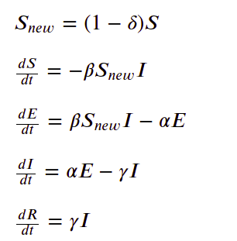

**Major Assumptions**

Major assumptions where things can go wrong are as follows.

1. Not all cases are being tested currently. Meaning that positive but asymptomatic people will not be in the list.
2. Suspected (Exposed) to Infected ratio: Due to people going out and attending dinners/parties - can be large (like patient 31 in Korea <<https://graphics.reuters.com/CHINA-HEALTH-SOUTHKOREA-CLUSTERS/0100B5G33SB/index.html>>)
3. All infected are quarantined (this efficiency keeps changing, across time and states)
4. Transmission to medical staff, and spread from there is currently unaccounted for.

**Data Requirements**

The variable required to estimate the spread rate, for a geographical location (city/hotspot/state) are the following.

1. Daily number of infected cases (Date X Confirmed cases data)
2. Infected to suspected ratio at the start of the modeling time (~2.4)
3. Population of the city/hotspot
4. Incubation time (~5.3 days - this is widely debated, India is checking for 28 days)
5. Infectious period (~2.3 days)